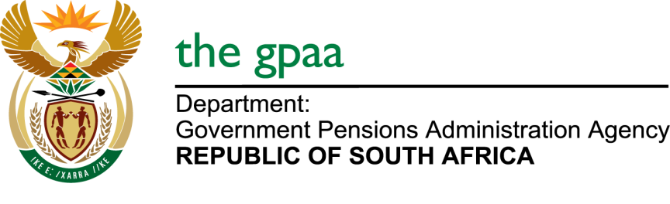

CLOSING DATE: 23 FEBRUARY 2017
CLEANING, HYGIENE AND PEST CONTROL SERVICES AT THE GOVERNMENT PENSIONS ADMINISTRATION AGENCY HEAD OFFICE AND GEPF REGIONALOFFICES FOR A PERIOD OF 36 MONTHS. GPAA 04/2017
NAME OF BIDDERS
- Delta Facility Management
- Risk Release
- Rams Garden and Cleaning Services
- Bonompho Cleaning Services
- Mobabo Hygiene Services
- Masana Hygiene Services
- Kameso Total Hygiene
- Mary Corporation
- Tshiamo Chemistry
- Xolisisizwe Trading and Projects
- Staza Cleaning Services
- Portia Nkone Trading & Project (JV)
- Sikhulile Primary Co-Operative
- Sidze Pest Management

